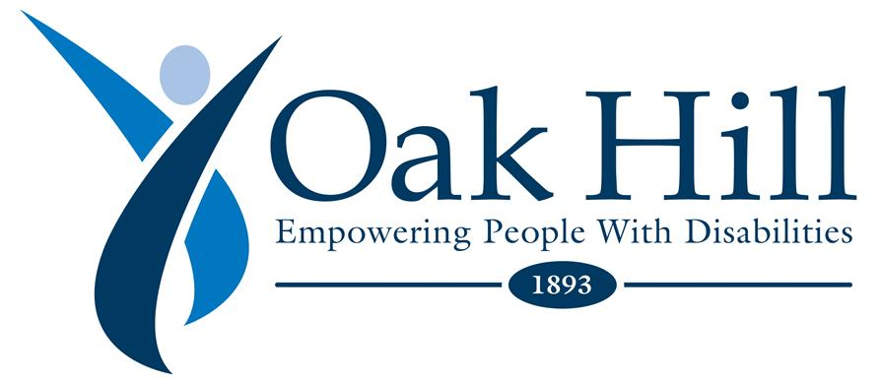

March 31, 2020

Dear Oak Hill Staff and Board,
I want to update you on where we stand amid the COVID-19 crisis. I also want to take a moment to thank you all who have been working around the clock to help protect and support the people that we serve. Your commitment is recognized by fellow staff, board members, and families. As I have been on many calls this week with state leaders and specialists, because of your dedication to our mission, we are continuing to set the standard compared to our peers, both locally and nationally.
We are in daily contact with local and state health officials, receiving appropriate guidance and support, and are acting on the most up to date information. Oak Hill is monitoring and continually adapting to meet the latest recommendations from the Centers for Disease Control and Prevention (CDC) and the Connecticut Department of Public Health (DPH).
Below is a list of some of the actions Oak Hill has taken to safely protect our clients and staff:
- Reviewing, updating, and implementing more aggressive infection control procedures;
- Remaining in communication with local community leaders, emergency management and response teams, elected officials and various state departments with which we contract;
- Participating in frequent meetings with our leadership teams and increasing the speed and frequency of staff communication;
- Taking active steps to prepare for possible disruptions caused by unplanned changes in staff;
- Implementing a strict “no visitors policy” throughout our programs; and
- Administrative staff are now working remotely from home.

In addition to these steps, we have taken further measures because of a known or suspected case of Coronavirus in our organization. We have notified all staff who may have had contact with this person so that they can reach out to their healthcare provider to be advised on next steps that should be taken. After consulting with infectious disease professionals, we have placed certain staff in self-quarantine based on a thorough evaluation, using the CDC risk assessment tool. Staff who were not notified directly about this situation, or placed in self-quarantine, have not come into contact with this person.
Here are additional actions that we have taken as a result of this situation:
- We continue to urge you to follow the CDC guidelines that we have sent out and follow the steps outlined in the memos sent on 3/16, 3/20 and 3/27 to make sure that you take the proper steps to protect your health and the health of those around you.
- We have added a new support link on the intranet to keep you connected to the latest updates and information related to Oak Hill’s response and planning around COVID-19.

Stay healthy. We will continue to update you as often as possible.

Sincerely,

Barry Simon

