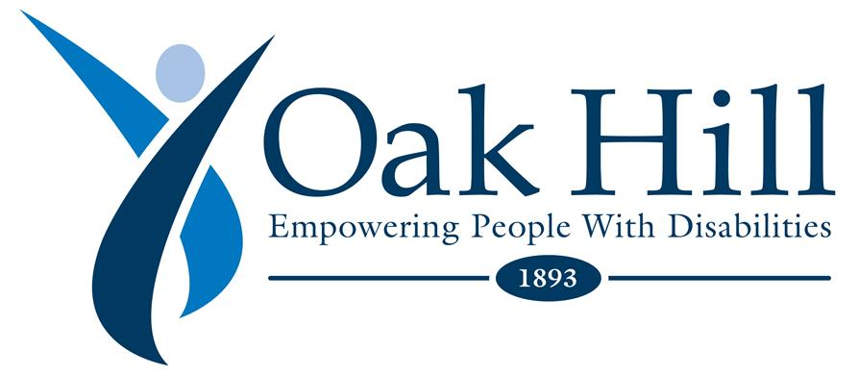
Update: March 27, 2020
Dear Devoted Oak Hill Staff,

I am writing to update you on where we stand during the COVID-19 crisis. I also wanted to thank the courageous and heroic staff members, that have been working nonstop to help protect and support our individuals. This commitment is recognized by fellow staff, board members, and families. The dedication to our mission is commendable, and we all in administration thank you.

We continue to be in daily contact with local and state health officials, receiving appropriate guidance and support, and are acting on the most up to date information. Oak Hill is monitoring and continually adapting to meet the latest recommendations from the Centers for Disease Control and Prevention (CDC) and the Department of Public Health (DPH).
Below is a list of actions already taken by Oak Hill to continue to safely protect our individuals and staff:
- Reviewing, updating, and implementing more aggressive infection control procedures
- Remaining in networked communication with local community leaders, emergency management & response teams, elected officials, and various state departments with which we contract
- Daily meetings with the senior leadership team and increasing the speed and frequency of staff communication
- Taking active steps to prepare for possible disruptions caused by unplanned changes in staff availability, medical conditions, and/or medical supply levels.
- Promoting Oak Hill community awareness through personal, digital, and social media outlets
- Waterbury day program is closed indefinitely
- Both Camp Hemlocks and Camp Harkness have been cancelled for Summer 2020
- Oak Hill schools, along with all Connecticut schools are closed at least until April 20, per Governor Lamont. We are working on implementing distance learning and support to students
- Per Governor Lamont’s Executive Order, Oak Hill group homes will impose a complete ban on all visitors to all group homes for a period of thirty (30) days
- Oak Hill administrative staff is primarily working from home
- Conducting all meetings of five (5) staff members or more by telephone or live stream video
- Oak Hill continues with the heightened cleaning protocols recently put in place. Sanitizing with hand washing upon entering the facilities will be required. Our Facilities team has implemented enhanced deep cleaning of high traffic touch points

I will continue to send you COVID-19 communications weekly. During these difficult times, we must remain united and maintain the most positive outlook on the future. Let’s continue to do what we do best; empower individuals with disabilities and empower one another.

With Gratitude,

Barry M. Simon

