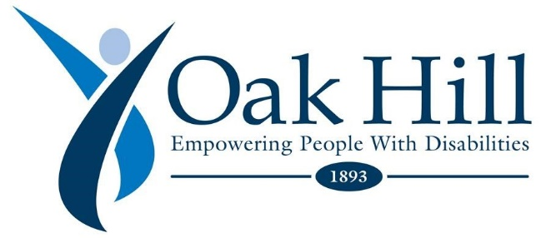

COVID-19 Update May 8, 2020

Dear Oak Hill Team,
Please remember, for the most up to date data of confirmed COVID-19 cases identified within the Oak Hill programs visit: https://intra.oakhillct.org/covid-19-communications/
It is not a secret that we’re living in a unique, difficult, and historic time. A time filled with many uncertainties. A time where a virus is changing everything about life and work as we know it.
But even in a time of disruption, it’s comforting to see businesses and organizations such as ours, focus on how to best protect and support our students, individuals, and employees. No matter what continues to unfold before us, it is about putting our people first.
I’ve often spoken about the importance of collaboration across our industry. And there is no better time like the one we are in now, to continue to come together and help one another navigate the challenges that lay before us. Now is the time to focus on the impact our mission has on everyone collectively, under the Oak Hill umbrella.
As we press on, providing the vital and imaginative services that we do, I hope each of you recognize how critical your role is at this agency. The ability to support and collaborate with one another is what will get us through this. You continue to amaze me with your innovative and engaging determination. I would like to share with you just a few (the dozens) of continuous collaborations that have occurred over the past several weeks.
Brief Collaboration Highlights:
- Scott Esson of Oak Hill School is joining forces with the Community Programs team, Operations team, and Development team to make ear-savers on the 3-D printer. Scott is working diligently to produce as many as possible to meet the needs of the nurses, RPW’s, and teachers who need ear relief from the countless hours of mask-wearing. Thank you, Scott!
- The Operations team continues to proudly collaborate with every Oak Hill department on everything from PPE drop-off & delivery, Amazon wish-list donations & delivery, and sanitation. We would like to extend a special shout-out to Claudia James and Leigh-Ann Hammond, who are working around the clock to ensure that these necessary items are not only arriving at Oak Hill, but also being distributed to the programs in need. Thank you for everything ladies. Keep up the good work!
- The Community Programs teams have continued to collaborate with other various programs to keep everyone safe with the mask donations. I would like to give a special shout out to Elise Suchocki, Speech Language Pathologist. She has been sewing and gathering donated fabric to make masks for all locations. She has been personally delivering them along with little treats to show staff appreciation. To date, she has delivered 1000 masks! Thank you, Elise!
As you can see, collaboration is vigorous now and as we proceed into the future. I remain committed to keeping you informed and updated each week about how we are faring now, our plan to move forward, and everything in between.
Thank you for your persistence, resilience, and your hard work.
Sending warm wishes on this Mother’s Day weekend!
Stay Healthy,
Barry
Stay Connected Here:
- Parents & Guardians resource and update page (we will continue to update this with resources, updates, and policy information) https://oakhillct.org/
- We strongly urge you to continue to follow the CDC guidelines found here:
https://www.cdc.gov/coronavirus/2019-ncov/index.html
- Can you help? Below is a list of ways you can contribute to those in need here at Oak Hill during this crisis. Any efforts made from this list, are greatly appreciated. Click here for list: https://docs.google.com/forms/d/e/1FAIpQLSex53WoL5mTixhqQLMTz2o4fO01e7QfNWCy-3vpvAmnYumUXw/viewform
- Email our Coronavirus Task Force with questions & concerns at: CoronaResponse@oakhillct.org

