Dear Oak Hill Team,

### As we conclude another week during the COVID pandemic, I would like to remind you of my appreciation. Your commitment to Oak Hill strengthens our capacity to transform the care for the people we serve, advance in the services we offer, engage with families in need, and improve the health of communities across Connecticut. My gratitude runs deep. Your support to protect against COVID-19 helps us lead the way, setting the standard in ways that only Oak Hill has, for over 125 years. Thank you.

### Additionally, I am including a reminder about the Oak Hill Town Hall meeting that will occur next Tuesday, May 19th, we invite all staff to participate. We will talk about the pandemic and answer questions that have been pre-submitted. These questions will be answered by myself and/or the Oak Hill leadership team.

This meeting is part of our evolving efforts to maintain a constant line of open communication with the Oak Hill community, and regularly update you on our progress and plans to reintegrate to the new “normal” operations.

**\*You must pre-register to attend one of the meetings.**

**ACTION REQUIRED: Immediately reserve your seat for a Town Hall Meeting, by clicking on the link below to register no later than Friday May 15, 2020:**

[**https://oakhillct.wufoo.com/forms/oak-hill-virtual-town-hall/**](https://oakhillct.wufoo.com/forms/oak-hill-virtual-town-hall/)

**In case you missed it!**

Yesterday, the Connecticut Air National Guard conducted a flyover to honor and recognize our healthcare heroes (that’s YOU!) The National Guard flew over various towns throughout the state at different times in a C-130H aircraft. Please see the picture below of the plane making its way Meriden, CT yesterday morning.

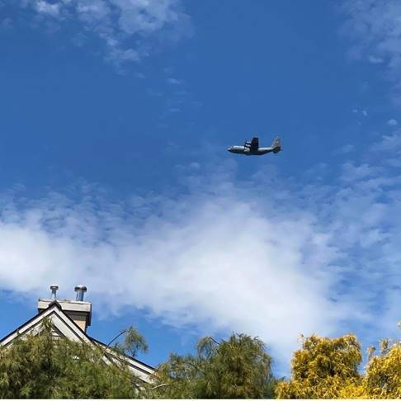

These are extraordinary times.   
  
Thank you for standing with us and remaining Oak Hill Strong!  
  
With much appreciation and gratitude,

Barry



Please remember, for the most up to date data of confirmed COVID-19 cases identified within the Oak Hill programs visit: <https://intra.oakhillct.org/covid-19-communications/>

**Stay Connected Here:**

1. Parents & Guardians resource and update page (we will continue to update this with resources, updates, and policy information) [**https://oakhillct.org/**](https://oakhillct.org/)
2. We strongly urge you to continue to follow the CDC guidelines found here:[**https://www.cdc.gov/coronavirus/2019-ncov/index.html**](https://www.cdc.gov/coronavirus/2019-ncov/index.html)
3. Can you help? Below is a list of ways you can contribute to those in need here at Oak Hill during this crisis. Any efforts made from this list, are greatly appreciated. Click here for list: [**https://docs.google.com/forms/d/e/1FAIpQLSex53WoL5mTixhqQLMTz2o4fO01e7QfNWCy-3vpvAmnYumUXw/viewform**](https://docs.google.com/forms/d/e/1FAIpQLSex53WoL5mTixhqQLMTz2o4fO01e7QfNWCy-3vpvAmnYumUXw/viewform)
4. Email our Coronavirus Task Force with questions & concerns at: [**CoronaResponse@oakhillct.org**](mailto:CoronaResponse@oakhillct.org)